Cheam Squash AGM – March 2025
At Cheam Sports club meeting room 7:45pm

Agenda

- 01 - Finance to date
- 02 - Club Rent
- 03 - Club Membership fees
- 04 - Club Maintenance
- 05 - Re-fit of court 2
- 06 - Team Squash
- 07 - Sat Night Mix-In Squash
- 08 - Club Tournaments and Events
- 09 - Guests, club rules & inappropriate use of guest rules
- 10 - Committee – Roles & Responsibilities
- 11 - Any other business

01 - Treasurer’s Summary

January 1st 2024 – December 31st 2024
Year 2024 Current A/C Savings A/C Totals
Start 14643.21 24232.79 38876.00
End 8468.47 36865.61 45334.08
Change -6174.74 12632.82 6458.08

Income
Stripe (Membership and court fees) £37,764 (£36351 in 2023)
Juniors (less assistant coaching costs and ad hoc costs e.g. trophy fees) £835
Interest £392

Outgoings
Rent £16650
Lead Coach, Cleaning £ 6529
Maintenance £3360
New doors £ 4860
Table Tennis Table £450
My Courts £648
BT £201
England Squash £225.00 (was £2708 in 2023, Big saving)

Current Balances (28/01/25)
Current Account £5347.70
Savings Account £40885.61
Total £46,233.31

02 – Club Rent

As in the past, we as a club have been very lucky with the help and good relationship with Cheam Sport Club and this year is no different. After meeting with Cheam Sport Club committee, it has been agreed that the rents for all sections will only go up 2% which is an amazing help to all sections of the sports club. This means that our rent this year will only increase by £333, bringing our new rent to the Sports Club to £16,983

03 - Club Memberships & fees

Following changes at England Squash, the club is no longer responsible for individual squash members. The main effect of this is that members are no longer covered by England Squash insurance.
It is advisable to take the insurance directly from England Squash, especially if members are playing Team squash etc.
Basic membership “Just Play” is £15 p.a. Details can be found here -
England Squash | Membership
https://membership.englandsquash.com/
There are other benefits such as a free Squash Player Magazine, and various discounts.

This year we have also agreed a change in the Table Tennis memberships, and some of you may already be aware of the changes we are making to Table Tennis membership.
From 1st April 2025 we are discontinuing a separate membership category of Table Tennis.
Those who wish to play table tennis at the club, will need to have a normal membership, just like any other users. The thinking behind this is, playing table tennis uses a court in the same way as playing squash or racquet ball.

With this in mind membership fees are to stay the same as last year, therefore the rate are:

FULL MEMBER ……………………………….. £190
OFF-PEAK MEMBER………………………… £115
JOINT MEMBERSHIP……………………….. £310
FULL TIME STUDENT………………………..£60
JUNIOR’s U19 (as of 1ST April)…………. £30
SOCIAL MEMBER……………………………. £25

We are also making changes to off-peak memberships be it Squash, Racquetball and Table Tennis. These members cannot book a peak time court,
But can now play at any time if the court is booked by a ‘FULL’ member (or equivalent), without paying a guest fee.
Current table tennis members will have their membership changed to Off-Peak before renewal notices are sent out.
Current membership numbers are :
FULL MEMBER …………..……….. 93
OFF-PEAK MEMBER………….… 37
JOINT MEMBERSHIP……..…….. 16
FULL TIME STUDENT…… ……..2
JUNIOR’s U19………………..……. 35
SOCIAL MEMBER………………. 3
TOTAL number of members 187
04 - Club Maintenance

Money within the club has been spent as and when needed as stated in the finances but of course our main purchase and improvement at the club has been the New Glass Doors on all courts and money well spent we feel especially when coaching juniors etc. Lighting around the changing rooms has been upgraded to LED and we are currently having the Air Vent in the gallery fixed to aid ventilation in the summer months

Plans are also to have the men’s shower floor relayed to avoid water spillage into the changing room area.
After many years of service, we also looking to upgrade the boiler at the club, this will be partly paid for by Cheam Sports club as they will pay for half if not all the cost of the replacement. And finally upgrade the balcony from painted wood and steel to NEW Glass and Stainless rails to make viewing games a lot easier especially during team matches and modernise the look of the club and try to bring in new members.

05 – Re-fit of Court #2 along with the maintenance of courts #1 & #3

Our next upgrade is to have court #2 floor replaced with new flooring and support system, All courts will have their walls professionally cleaned, courts 1 & 3 will have the court floor sanded and new lines added, Court 3 will have its walls repaired and painted with a new technology paint system, and final each air vent above the front wall of each court will have the vent reopened and new grills installed . This will cost £12,748 and will make our club look brand new

06 – Team Squash and Racquetball

So, this year we have had a great year for team Squash and Racquetball with all team playing so great games over the year and a good social event each time games are played.
Currently we have :- Lady’s Squash Team,
Vintage Team (50 for women and 55 for men) Squash
Racquetball 1st Team
Racquetball 2nd Team

But we have NO Men’s Team and I would like to have a team put together for the next Summer leagues

SO, IF YOU ARE ABLE TO BE PART OF A MEN’S TEAM AND WISH
TO HELP THE CLUB BY BEING A ‘CAPTIAN’
WE WOULD LIKE TO HEAR FROM YOU

This will be more of a social team and league for players wishing to experience playing other players from other clubs and visiting new clubs in the process, these clubs are local so don’t be too worried.

Our Current teams have just finished their Winter league 2024/25 and the league standings are listed below.

We will also be fielding a New Junior team which will start in October 2025 and we will be asking parents if there child would like to be part of this. We will need players names by 7th July so we can entre them into the Surrey Squash register.
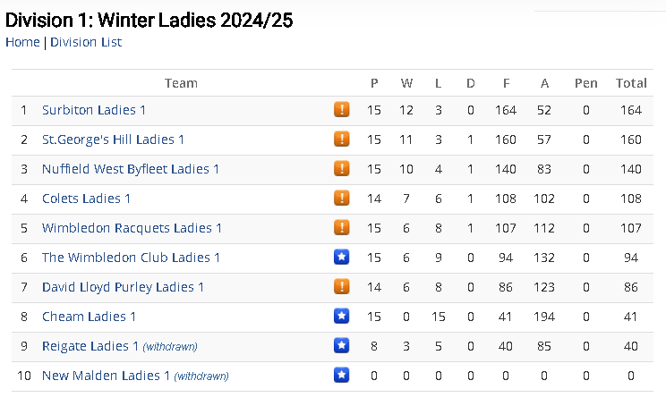

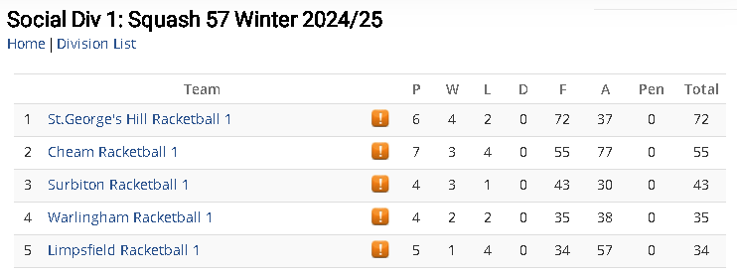
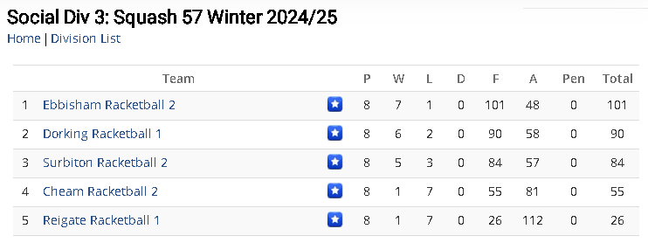
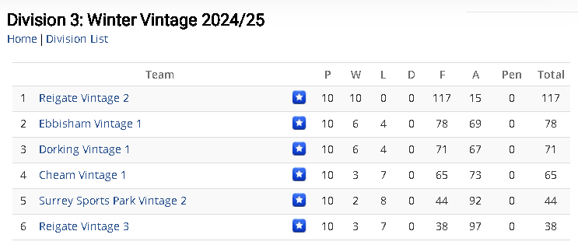

07 - Sat Night Mix-In Squash

We are glad to hear that club night is well attended and members meeting on a Saturday to play each other,
We will be starting a register of players that attend the session to see how well we are doing. It has been mentioned that there are some players that are forgetting to pay for the Club Night Session which I am sad to hear especially seeing as its only £4. This is a great price for over 2 hours of court time.

PLEASE be aware that as of the 1ST April “CLUB NIGHT” will be £4.00

08 - Club Tournaments and Events

Last year sore the re-start of the club tournaments both of which where the Ladies and the Men’s Squash Club Championships with champions being Betsy Drury for the ladies and Oliver Colgate for the men.
This tournament will of course happen again this year

We also held a Club handicap in February and after 6 or 7 games against various opponents Jonathan McCabe and Ken Self, made it to the Squash Handicap Final. After such a good match, there can be only one winner, and congratulations goes to Jonathan McCabe who won 3-0. Well played guys

We will have another event around easter and will let everybody know once plans have been made.

There will also be an event this year where we will play Squash, Racquetball and Table tennis in one event, again more details as we get them.

09 - Guests, club rules & inappropriate use of guest rules

It was spoken about off-peak members playing Peak members in peak times this was covered in
section 03 and 07 above

Please also keep an eye on the club court bookings, if you turn up at the club and see there are players playing on court, but they have not booked, PLEASE could you ask if they have made a booking, as we have had members reporting players playing on courts that have not been booked on the systemand some may of played without paying for the court.

*Important Notice *
If anyone is found doing this, you will have to answer questions from the club committee. So please pay for your courts before you play.

**Remember, this club is run by members, for members **

10 - Committee – Roles & Responsibilities

Chairman | Chas Baldacchino
Vice Chairman | Richard Clasby
Treasurer /Club Secretary | Simon Price
Membership Secretary | Chas Baldacchino
Racquetball Captains | Nathan Newark  Chas Baldacchino
Ladies Captain | Helen Fowler
Vintage Captain | Jimmy Demetriou
League Secretary | Jamil Qurashi
Squash Coaching | Natalie LeServe-Ort  Jorge Martinez
Club Technology | Nick Russell
President | Graham Raincock
Vice Presidents | Chris Wright

11 – Any Other Business

A big thank you to Jan Kidacki who has kindly started up a mid-week squash social which is on a Wednesday but can be any day that a group of players wish to make it. They are currently using the Cheam Squash Club community WhatsApp group to communicate.

It has been bought to our attention that the upkeep of the Defibrillator has been covered by a club member for a number of years which we have been unaware off, but this will now be taken over by the club and will be maintained by the club on a year basis and we will be sure to have spares kept at the club at all times.

Also, it has been asked that we keep the notice boards up to date with club notices and events. And we will be keeping an eye on this too.

If there are any other quires you wish to be discussed at the next committee meeting, please pass them on to us by the 20th May.

Thank you ALL

Kind regards

Charles Baldacchino
Cheam Squash Club Chairman

